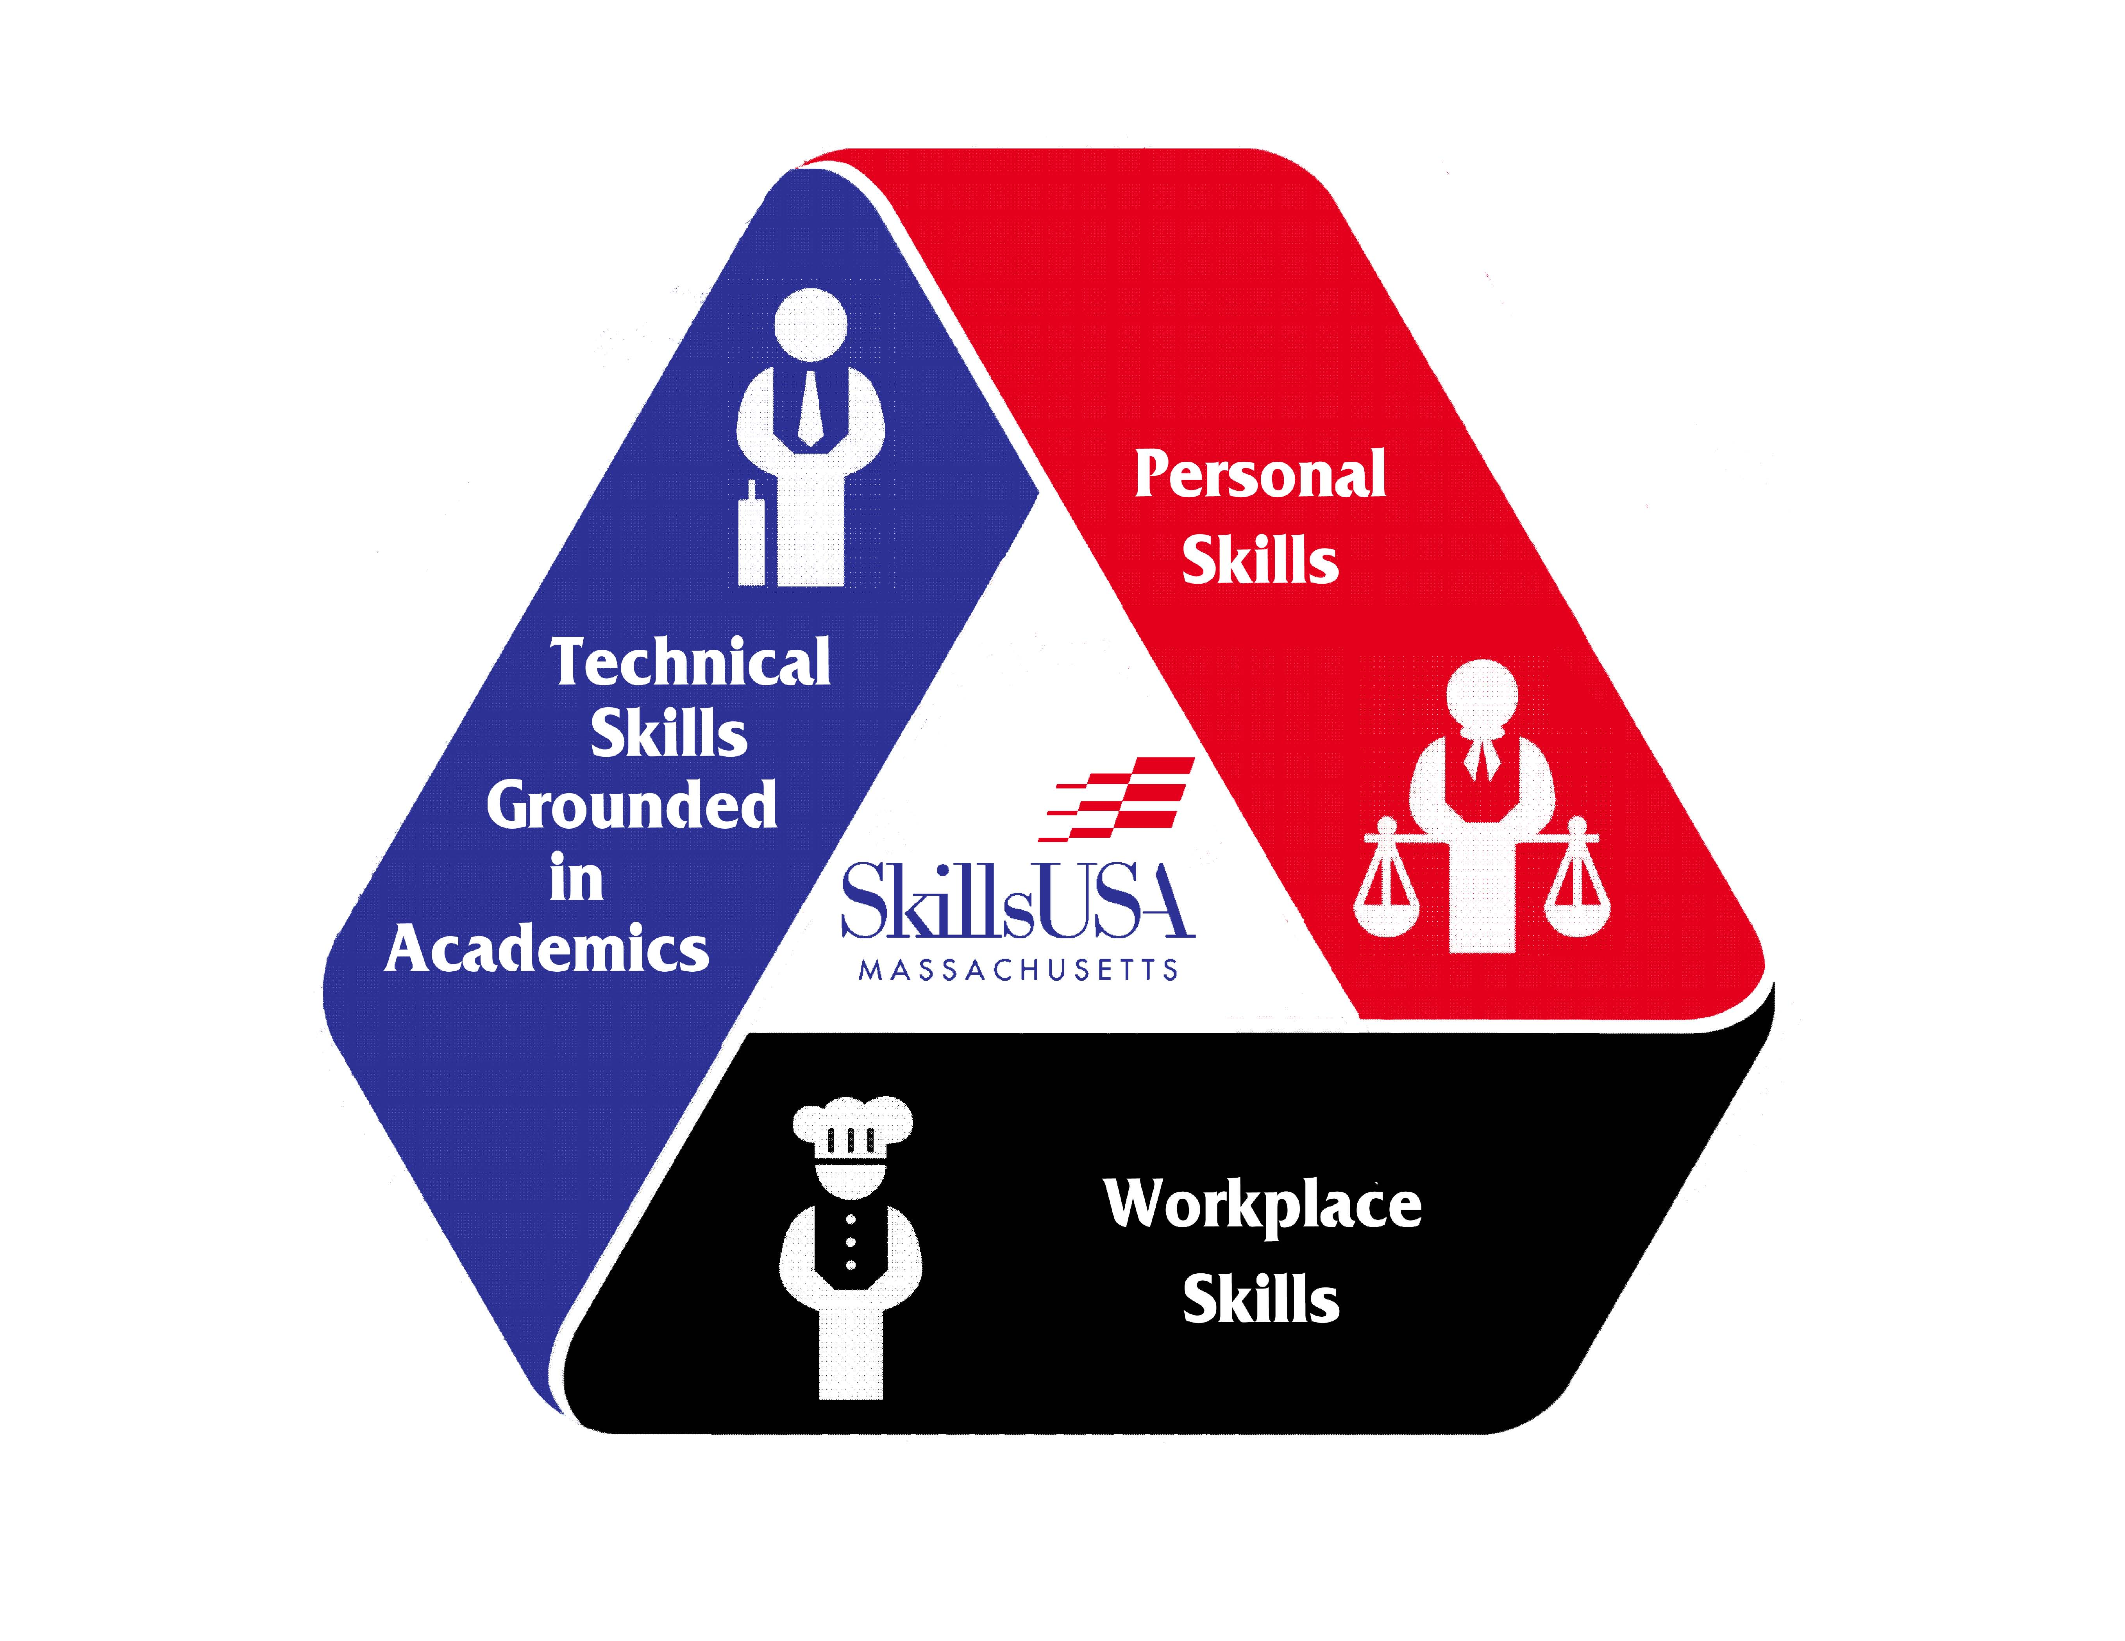
STUDENT ADVISORY COUNCIL
APPLICATION
Please Fill out and return to the state office.
First Name |  | Last Name:
Trade/ CTE Program: | Grade: | School:
Address:
City: |  | Zip: | Home Phone:
Mobile Phone: |  | Email:
Advisor/Instructor: |  | School Telephone:
Advisor Email:
Complete School Address:

Have you attended a SkillsUSA conference? If Yes, which?
Extracurricular Activities
Please provide a brief description of your Extracurricular Activities.

Short Essay
Please write an essay of not less than 300 words and not more than 500 words describing why you would like to serve on the State Conference Advisory Council for SkillsUSA Massachusetts. The 300–500 word essay must be typed in the space provided below or printed on a separate piece of paper from a word processor, and be attached to this application.
Agreement
I hereby understand that if I should be selected to serve as a SkillsUSA Massachusetts National Voting Delegate that:
I hereby understand that if I should be selected for the State Conference Student Advisory Council that:
- I must attend both of the council meetings (please see State Calendar for time, date, and location information) and should be present for all of the discussions;
- All Committee members are expected to participate to the best of their ability; and
Your Name |  | Your Signature |  | Date
Parent/Guardian’s Name |  | Parent/Guardian’s Signature |  | Date
Chapter Advisor’s Name |  | Chapter Advisor’s Signature |  | Date
Shop Department Head’s Name |  | Shop Department Head’s Signature |  | Date
Should have a grade point average of a C or better in each class academic and trade to fulfill the requirements as a committee member.

Note: You and/or your SkillsUSA Chapter are responsible for transportation to and from the meeting site. If your advisor is driving, he/she will not be participating in the meeting.
Please mail this application, postmarked by January 29th to the following address to be accepted for consideration.
State Conference Advisory Committee Application
C/o SkillsUSA Massachusetts
250 Foundry Street
South Easton, MA 02375
Or
Email kward@maskillsusa.org

