First Name | Last Name:
Trade/ CTE Program: | School:
Address:
City: | Zip: | Home Phone:
Mobile Phone: | Email:
Advisor/Instructor: | Advisor Instructor phone:
Advisor Email:
Complete School Address:

Submissions should be mail to:
State T-Shirt Design Contest
c/o SkillsUSA Massachusetts
250 Foundry Street
South Easton, MA 02375

Signature of Application | SkillsUSA Advisor/Instructor Signature
Date | Date

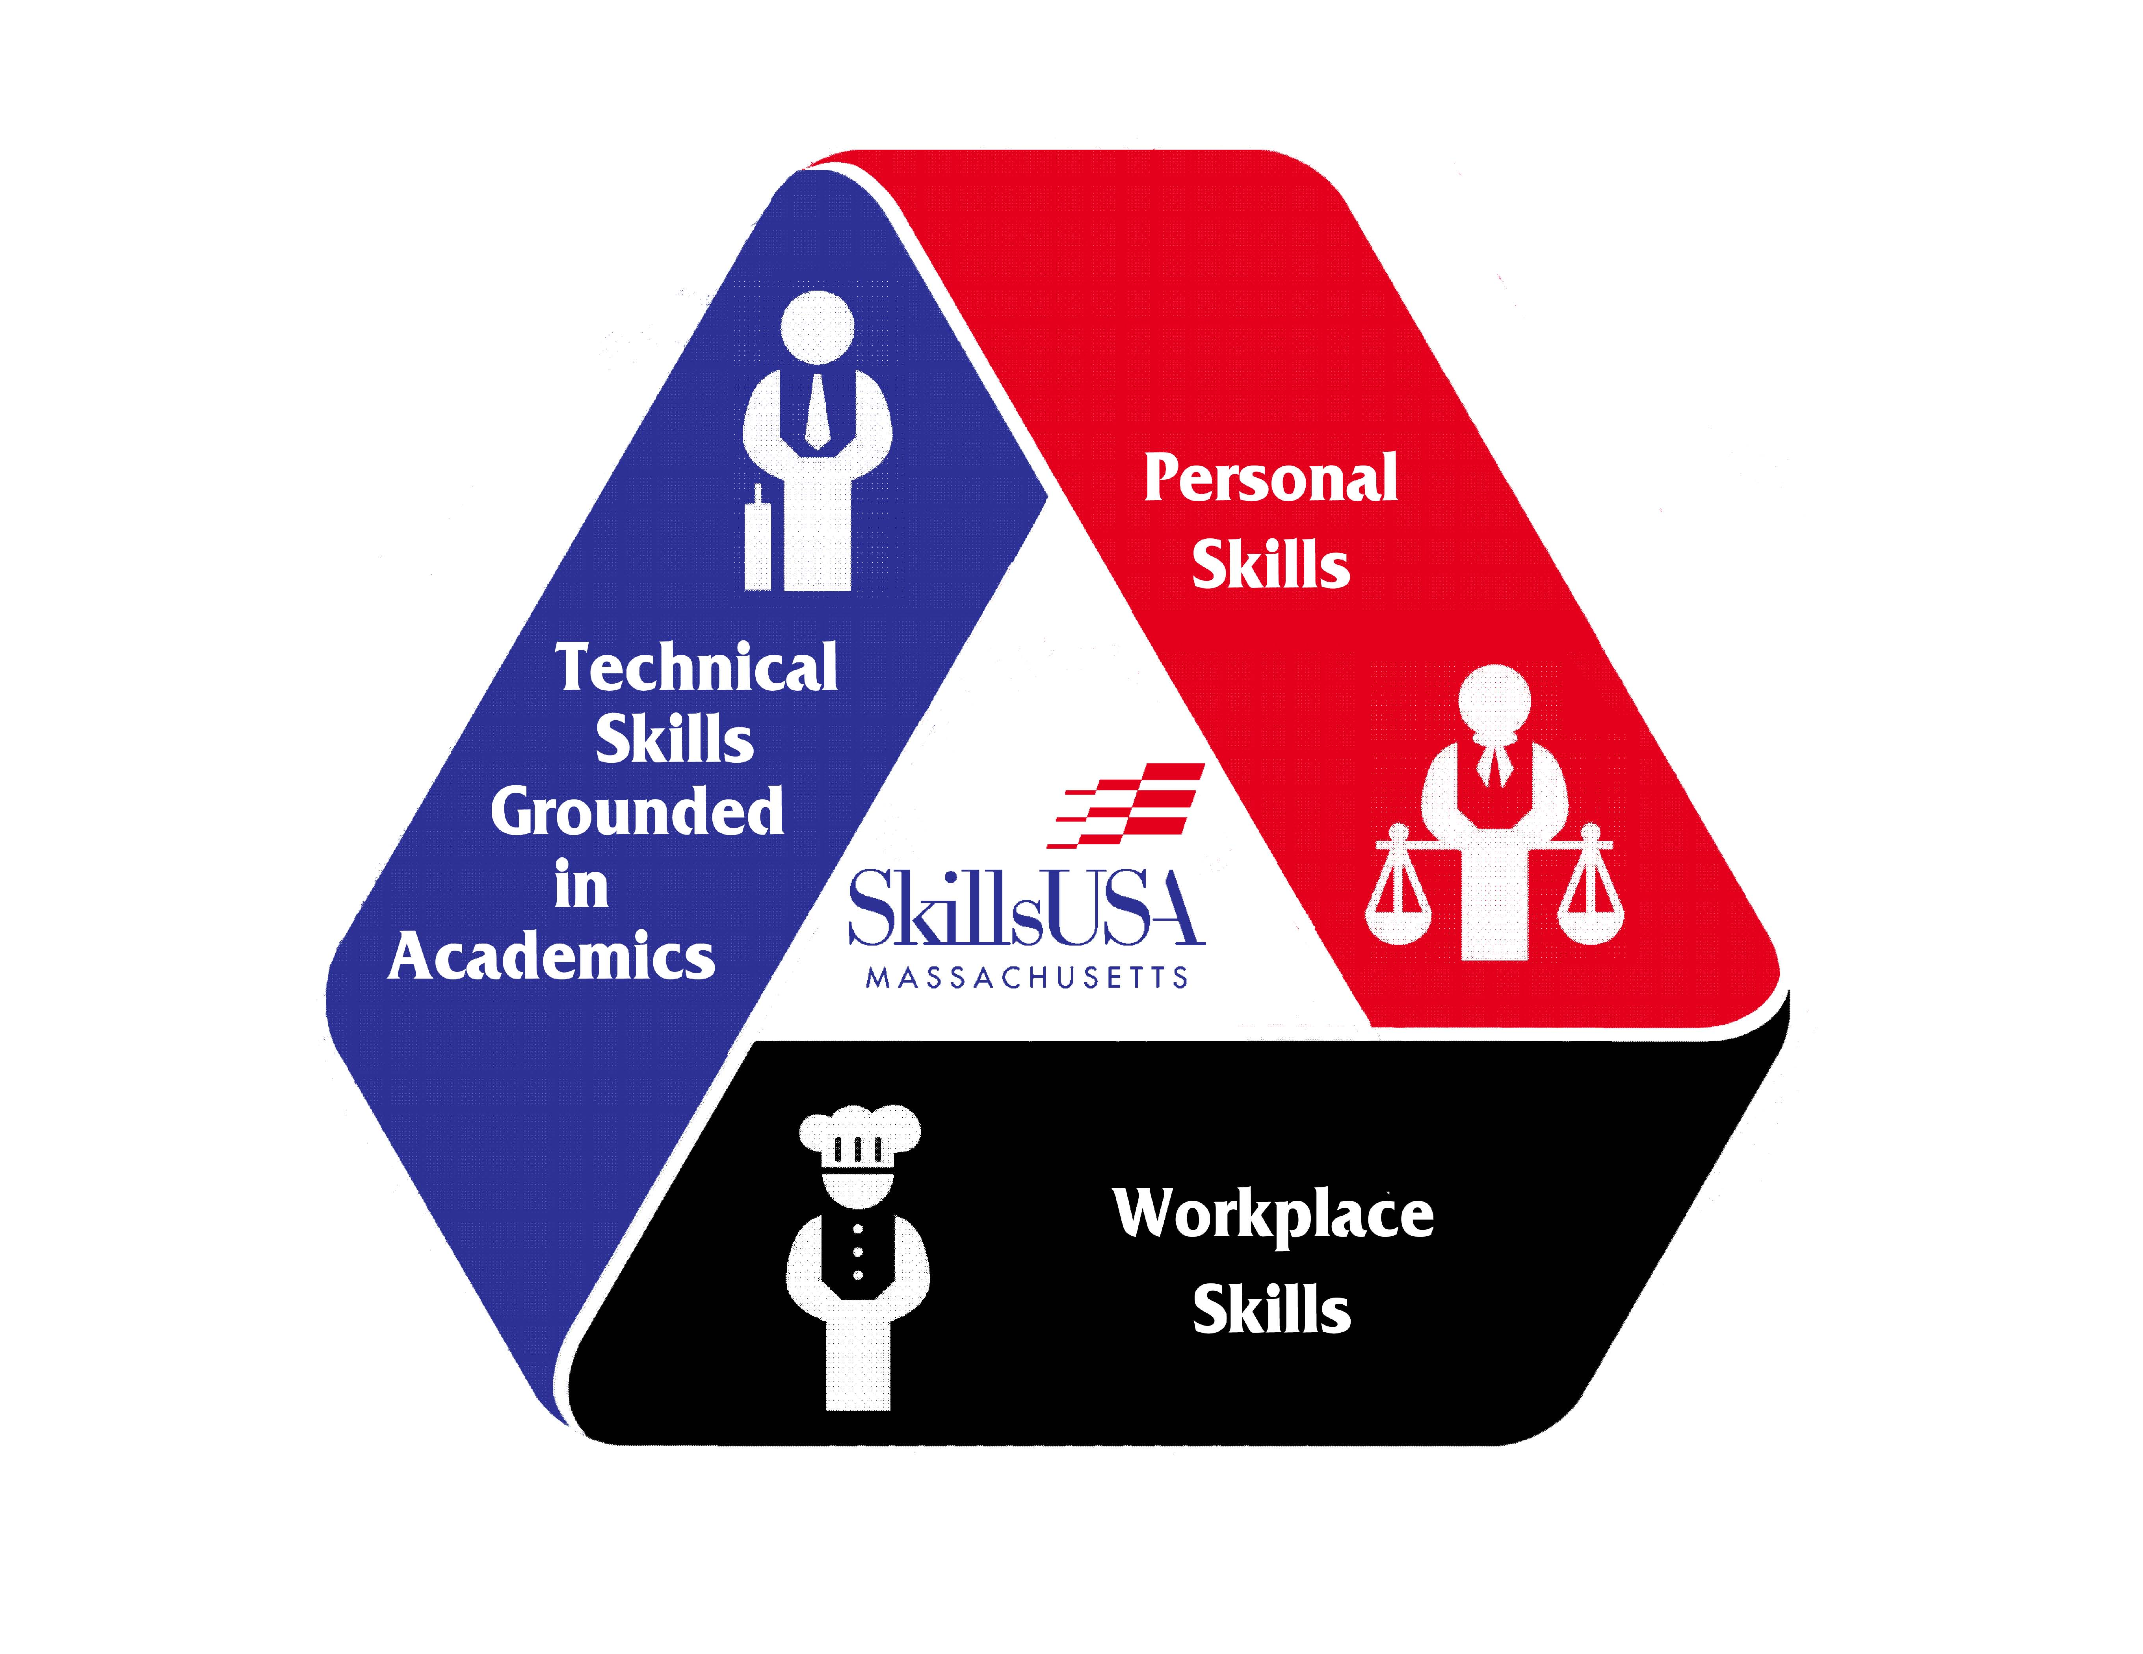
STATE T-SHIRT DESIGN CONTEST

Official State Leadership & Skills Conference T-shirt
The winning design in this category will be produced and worn as the Official Massachusetts SkillsUSA Championships Competitor T-shirt at the State Leadership & Skills Conference. The winner will receive a free trip to the State Leadership and Skills Conference. In addition, the designer (with an illustration of the design) will be acknowledged in the SkillsUSA Massachusetts Championships Program.
Eligibility
This contest is open to all paid-in-full SkillsUSA Massachusetts members for the current academic school year, secondary and postsecondary.
Branding
The brands “SkillsUSA” and “SkillsUSA Massachusetts”, as well as the SkillsUSA and the SkillsUSA Massachusetts logos, must conform to the usage guidelines on pages 3–11 of the Graphics Standard Manual, available for download here:
skillsusa.org/downloads/PDF/Graphstandrds.pdf. Incorrect usage of the brands and/or logos will result in disqualification of the entry.
Submitting your design
Be sure to securely attach the registration form to the back of the design for consideration. In addition, the front facing side of the design or board on which the design is attached to should not contain any elements that may identify the designer (this information should be on the registration form.) The deadline for the entry is December 31st, postmarked.

T-shirt Requirements
- Comp large size: No smaller than 4"
- Shirt color: White
- Color: Four spot colors may be used, black is considered a color
Medium: Computer generated or Hand drawn
- Imagery: Type, illustration, graphic representation, or all mentioned.
- State Conference Design
- (2nd T Shirt) National Conference

Content:
SECOND T-SHIRT

SkillsUSA Massachusetts
2017
“Preparing America’s Skilled Workforce”
or
SkillsUSA “LOGO,”
National Leadership & Skills Conference
SkillsUSA Massachusetts
2017
“Preparing America’s Skilled Workforce”

April 30th, May 1-2, 2015
FIRST T-SHIRT

“Connecting You to Career Success”
April 27th-29th, 2017
or
SkillsUSA “LOGO,”
State Leadership & Skills Conference
Massachusetts
2017
“Preparing America’s Skilled Workforce”
April 30th, May 1-2, 2015

Code Number Assigned:

